Serial debugging

**The Basics**

# lab: Interfacing w/ serial ports

**Lab Description:** In this lab you will identify the chipsets used (if there are multiple), their manufacturer, the serial debug type, and the pins used. Screenshots are required for each answer and should be submitted here, not as individual pictures. Wherever necessary, provide brief descriptions or explanations for your screenshot contents. For the first exercise all resources are provided. The second exercise is for extra credit and equipment will not be provided.

Check for errors throughout the entire process.

**Lab Environment:** The following image should be used to answer all questions for exercise one.

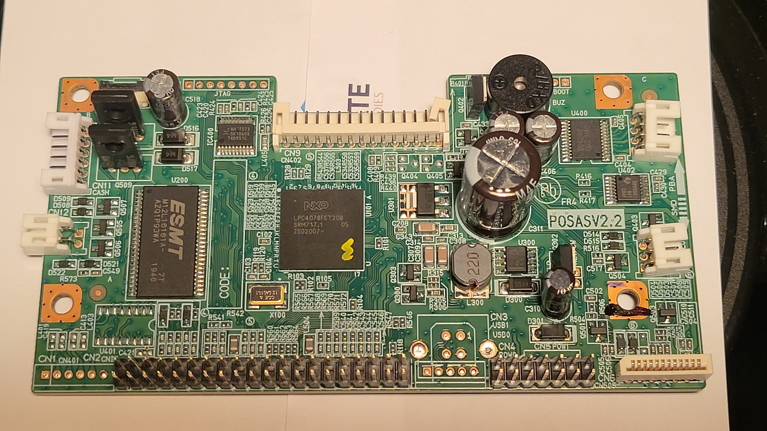

**Lab Files that are Needed:** If the provided image is still unclear after zooming in, the image has been provided as “device_board.jpg”.

### **Lab Exercise 1**

Using the provided photo of the target device, answer the following:

1. What is the serial number of the CPU used by the device? If you are unsure which is the main chip, provide a table of what you identified.
2. Who are the chip manufacturers? Again, use a table if you are unsure of which.
3. Which chipset do you think is the CPU, and what are the debug pins used? Provide a link to the datasheet used.
4. Which serial debug interface does this device use? Take a screenshot. There is only one.

### **Lab Exercise 2 (Extra Credit)**

Use a device of your own choosing and answer the same questions for the first exercise. Answer the following as well:

1. Answers for each of the questions asked in exercise one.
2. Show a screenshot of your target device’s board. Label the CPU and the header used for the serial debug interface.
3. Create a wire harness for the interface and attach a serial debugger. Show a screenshot of your harness with labels for each port (e.g. wire 1/yellow = TDI, wire 2/green = TDO, etc…).
4. Take a screenshot showing the device has been recognized. Check device manager or use dmesg for linux systems.
5. Use PuTTY or minicom and connect to the debugger. Do you have any output from the device booting up? Take a screenshot.

## What to submit

Submit your answers in a PDF with clear screenshots and explanations as directed, then label that file as “Lab1_firstname_lastname.pdf”. For the parts of the exercises that do require scripts, create plain text files to hold your script, and name the file containing your script as indicated in the problem instructions.